

ASSET VERIFICATION AND RECORDING TOOL KIT


Plot 31, Bukoto Street
P.O Box 7657, Kampala, Uganda
+256 (0) 39 2000216/0772525235
email: cpa@cpa.ug

www.cpa.com

August to September 2026

VERIFICATION DETAILS

NAME OF THE REGION: | GREATER MASAKA
SUB-REGION:
Name of Local Government | LWENGO DISTRICT LOCAL GOVERNMENT
VERIFIER PARTICULARS
Full name | NANTUMBWE PENINAH
Contact/ email and Telephone | 0704321431
Supervisor/ Sub team leader
Name | KALYOWA LAWRENCE
Contact | 0774106047
Date of submission

HEALTH CENTRES
INFORMANT INTERVIEW/DISCUSSION GUIDE (INCHARGE OR RESPONSIBLE PERSON)

Name of Health Centre: KAKOMA HEALTH CENTRE III

1a | Does the Facility have a record of all assets provided under UgIFT.  (Obtain a record and verify if it has the costs and numbers supplied | Yes
1b | If Not ask how many were supplied and when.

2 | How does this facility Maintain (repair/service/replace) the assets provided under Ugift

They get funds from different areas

3 | Does the facility take regular record about functionality/ or breakdown of the assets provided? | Yes

4 | How has the UgIFT support helped in service delivery in the area, any issues, challenges and any recommendations for better program implementation.

Challenges
- They don’t have electricity.
- They don’t have enough nurses and doctors
- They lack experience in using these machines
- They don’t have proper means of transport
- Some things came when they don’t work.

Recommendations
- Putting proper electricity
- Getting more nurses and doctors
- Teaching them how to use these machines

PROCEED TO VERIFICATION AFTER THIS DISCUSSION

Health centre checklist

NAME OF LG: LWENGO DISTRICT LOCAL GOVERNMENT NAME OF HEALTH FACILITY: KAKOMA HEALTH CENTRE III

Equipment/ Item | Department | Asset Number | Item  Description | Life in Months | Tag Number ( engrave no.) | Date Of Purchase | Date Placed In Service | Recoverable cost | Cost | Acc Dep Cost | Net Book Value | Ytd Deprn | Equipment status | Remarks
B.P. Machine, Digital | OPD |  | They are 4 white in colour |  | Not  engraved | 30/6/2025 | 1/7/2025 |  |  |  |  |  | Good | Functional
B.P. Machine (Aneroid wall mounted) | MOH |  | They are 4 but not verified |  |  | 30/6/2025 | 1/7/2025 |  |  |  |  |  | Good | Functional
Autoclave 20 Liters.,Duo Operated | MOH |  | They are 5 white in colour |  | Not  engraved | 30/6/2025 | 1/7/2025 |  |  |  |  |  | Good | Functional
Bowl, Kick | MOH |  | It was 1 stainless steel |  | Not  engraved | 30/6/2025 | 1/7/2025 |  |  |  |  |  | Good | Functional
Bowl Stand | MOH |  | It was 1 white in colour |  | Not  engraved | 30/6/2025 | 1/7/2025 |  |  |  |  |  | Good | Functional
Counting chamber Neubauer- Improved | MOH |  | They are 5 grey in colour |  | Not  engraved | 30/6/2025 | 1/7/2025 |  |  |  |  |  | Good | Functional
Cupboard Steel, Lockable | OPD |  | They are 5 grey in colour |  | Not  engraved | 30/6/2025 | 1/7/2025 |  |  |  |  |  | Good | Functional
Drip Stand | Ward |  | They are 8 white in colour |  | Not  engraved | 30/6/2025 | 1/7/2025 |  |  |  |  |  | Good | Functional
ESR Stand | MOH |  | It is 1 with tubes |  | Not  engraved | 30/6/2025 | 1/7/2025 |  |  |  |  |  | Good | Functional
Examination Couch | MOH |  | They are 23 metallic |  | Not  engraved | 30/6/2025 | 1/7/2025 |  |  |  |  |  | Good | Functional
Examination light,LED | MOH |  | They are 3 but not verified |  |  | 30/6/2025 | 1/7/2025 |  |  |  |  |  | Good | Functional
Glucometer | MOH |  | They are 3 white and yellow |  | Not  engraved | 30/6/2025 | 1/7/2025 |  |  |  |  |  | Good | Functional
Haemoglobin Meter, Digital | MOH |  | They are 8 but not verified |  |  | 30/6/2025 | 1/7/2025 |  |  |  |  |  | Good | Functional
Height Meter | MOH |  | They are 3 white in colour |  | Not  engraved | 30/6/2025 | 1/7/2025 |  |  |  |  |  | Good | Functional
Instrument Trolley | MOH |  | They are 2 but not verified |  |  | 30/6/2025 | 1/7/2025 |  |  |  |  |  | Good | Functional
Microscope Binocular | LAB |  | It is 1 white in colour |  | Not  engraved | 30/6/2025 | 1/7/2025 |  |  |  |  |  | Good | Functional
Otoscope | OPD |  | Its 1 but not verified |  |  | 30/6/2025 | 1/7/2025 |  |  |  |  |  | Good | Functional
Patient Screen | OPD |  | They are 6 in metallic form with a blue cloth |  | Not  engraved | 30/6/2025 | 1/7/2025 |  |  |  |  |  | Good | Functional
Patient Trolley | MOH |  | They are 4 silver and black in colour |  | Not  engraved | 30/6/2025 | 1/7/2025 |  |  |  |  |  | Good | Functional
Refrigerator, Basic | MOH |  | Its 1 in grey basic brand |  | Not  engraved | 30/6/2025 | 1/7/2025 |  |  |  |  |  | Good | Functional
Stethoscope | MOH |  | They are 4 but not verified |  |  | 30/6/2025 | 1/7/2025 |  |  |  |  |  | Good | Functional
Stop Watch | MOH |  | They are 3 but not verified |  |  | 30/6/2025 | 1/7/2025 |  |  |  |  |  | Good | Functional
Stretcher | OPD |  | They are 4 black and grey colour |  | Not  engraved | 30/6/2025 | 1/7/2025 |  |  |  |  |  | Good | Functional
Stove, Gas | MOH |  | They are 2 white 6 kgs stabex |  | Not  engraved | 30/6/2025 | 1/7/2025 |  |  |  |  |  | Good | Functional
Weighing Scale with Height Meter, Adult | MOH |  | Its 1 but not verified |  |  | 30/6/2025 | 1/7/2025 |  |  |  |  |  | Good | Functional
Weighing Scale, Infant | MOH |  | They are 2 but not verified |  |  | 30/6/2025 | 1/7/2025 |  |  |  |  |  | Good | Functional
Weighing Scale, Toddler | MOH |  | They are 2 but not verified |  |  | 30/6/2025 | 1/7/2025 |  |  |  |  |  | Good | Functional
Wheel Chair | MOH |  | They are 4 black in colour with wheels and handles |  | Not  engraved | 30/6/2025 | 1/7/2025 |  |  |  |  |  | Good | Functional
Audio Visual Equipment
Medical Waste Bin | OPD/MOH |  | They are 4 blue in colour |  | Not  engraved | 30/6/2025 | 1/7/2025 |  |  |  |  |  | Good | Functional
Wall Clock | OPD |  | They are three gold and round |  | Not  engraved | 30/6/2025 | 1/7/2025 |  |  |  |  |  | Good | Functional
Diagnostic Equipment Set for MCH | MOH |  | They are 2 but not verified |  |  | 30/6/2025 | 1/7/2025 |  |  |  |  |  | Good | Functional
Diagnostic Equipment Set for OPD | OPD |  | They are 4 but not verified |  |  | 30/6/2025 | 1/7/2025 |  |  |  |  |  | Good | Functional
Glassware Set, Laboratory, Basic | LAB |  | They are 2 glassless and breakable |  |  | 30/6/2025 | 1/7/2025 |  |  |  |  |  | Good | Functional
Hollow Ware Set, Treatment | OPD |  | They are 5 but not verified |  |  | 30/6/2025 | 1/7/2025 |  |  |  |  |  | Good | Functional
Instrument Set, Dressing | MOH |  | Its 1 but not verified |  |  | 30/6/2025 | 1/7/2025 |  |  |  |  |  | Good | Functional
Instrument Set, Basic ENT | MOH |  | They are 2 but not verified |  |  | 30/6/2025 | 1/7/2025 |  |  |  |  |  | Good | Functional
Instrument Set, Suture | MOH |  | They are 3 but not verified |  |  | 30/6/2025 | 1/7/2025 |  |  |  |  |  | Good | Functional
Pulse Oximeter, Hand held | MOH |  | Its 1 nut not verified |  |  | 30/6/2025 | 1/7/2025 |  |  |  |  |  | Good | Functional
Bed, Adult Patient with Mattress | Ward |  | They are 18 metallic handles and black mattresses |  | Not  engraved | 30/6/2025 | 1/7/2025 |  |  |  |  |  | Good | Functional
Bed, Pediatric Patient, With Mattress | Ward |  | They are 5 with small addresses |  | Not  engraved | 30/6/2025 | 1/7/2025 |  |  |  |  |  | Good | Functional
Bedside Locker | OPD |  | They are 13 metallic grey steel |  | Not  engraved | 30/6/2025 | 1/7/2025 |  |  |  |  |  | Good | Functional
Cupboard, Instrument
Delivery Bed, Hydraulic Manual | MOH |  | They are 2 hydraulic |  | Not  engraved | 30/6/2025 | 1/7/2025 |  |  |  |  |  | Good | Functional
Oxygen Therapy Apparatus, Mininum 45L cylinder | MOH |  | They are 2 oxygen therapy minimum 45 litres |  | Not  engraved | 30/6/2025 | 1/7/2025 |  |  |  |  |  | Good | Functional
Resuscitator Manual, Infant, with all Mask sizes | MOH |  | They are 2 with all masks sizes |  | Not  engraved | 30/6/2025 | 1/7/2025 |  |  |  |  |  | Good | Functional
Resuscitator Manual, Adult, with all mask sizes | MOH |  | They are 3 but not verified |  |  | 30/6/2025 | 1/7/2025 |  |  |  |  |  | Good | Functional
Suction Apparatus, (Electric) | MOH |  | They are 2 electric apparatus |  | Not  engraved | 30/6/2025 | 1/7/2025 |  |  |  |  |  | Good | Functional
Nebulizer, Ultrasonic | MOH |  | Its 1 but not verified |  |  | 30/6/2025 | 1/7/2025 |  |  |  |  |  | Good | Functional
Oxygen Concentrator, Duo Flow | MOH |  | It is 1 but not verified |  |  | 30/6/2025 | 1/7/2025 |  |  |  |  |  | Good | Functional
Bench | OPD |  | They are 5 metallic vanished |  |  | 30/6/2025 | 1/7/2025 |  |  |  |  |  | Good | Functional
Disinfection Buckets | MOH |  | They are 8 normal form |  | Not  engraved | 30/6/2025 | 1/7/2025 |  |  |  |  |  | Good | Functional
Baby Cot | MOH |  | They are 2 silver in colour |  | Not  engraved | 30/6/2025 | 1/7/2025 |  |  |  |  |  | Good | Functional
Diagnostic Equipment Set for Ward | MOH |  | Its 1 but not verified |  |  | 30/6/2025 | 1/7/2025 |  |  |  |  |  | Good | Functional
Hollow Ware Set, Ward | MOH |  | They are 3 but not verified |  |  | 30/6/2025 | 1/7/2025 |  |  |  |  |  | Good | Functional
Instrument Set, Delivery | MOH |  | They are 6 but not verified |  |  | 30/6/2025 | 1/7/2025 |  |  |  |  |  | Good | Functional
Instrument Set, Stitch Removing | MOH |  | They are 2 but not verified |  |  | 30/6/2025 | 1/7/2025 |  |  |  |  |  | Good | Functional
MVA Kit | MOH |  | They are 6 but not verified |  |  | 30/6/2025 | 1/7/2025 |  |  |  |  |  | Good | Functional
Stool, Laboratory | LAB |  | Its 1 black in colour |  | Not  engraved | 30/6/2025 | 1/7/2025 |  |  |  |  |  | Good | Functional
Penguin Sucker | MOH |  | They are 3 rubber in nature |  | Not  engraved | 30/6/2025 | 1/7/2025 |  |  |  |  |  | Good | Functional
Fetoscope, Dopplar | OPD |  | Its 1 silver in nature with round top |  | Not  engraved | 30/6/2025 | 1/7/2025 |  |  |  |  |  | Good | Functional
Bubble CPAP |  |  |  |  |  | 30/6/2025 | 1/7/2025
Centrifuge (Electric) | MOH |  | Its 1 but not verified |  |  | 30/6/2025 | 1/7/2025 |  |  |  |  |  | Good | Functional
Kangaroo Mother Care Chair | MOH |  | Its 1 grey in clour |  | Not  engraved | 30/6/2025 | 1/7/2025 |  |  |  |  |  | Good | Functional
Radiant Infant Warmer |  |  |  |  |  | 30/6/2025 | 1/7/2025
Haemoglobin Meter, Sahli | MOH |  | They are 3 but not verified |  |  | 30/6/2025 | 1/7/2025 |  |  |  |  |  | Good | Functional
Delivery Bed | MOH |  | They are 2 with delivery beds |  | Not  engraved | 30/6/2025 | 1/7/2025 |  |  |  |  |  | Good | Functional
Examination light | OPD |  | They are 2 with bulbs |  | Not  engraved | 30/6/2025 | 1/7/2025 |  |  |  |  |  | Good | Functional
Instrument set, ENT Basic for HCIII | OPD |  | They are 2 but not verified |  |  | 30/6/2025 | 1/7/2025 |  |  |  |  |  | Good | Functional
Bag Valve mask (Ambu Bag), Neonatal | MOH |  | They are 4 white with yellow glass with a tall mask |  | Not  engraved | 30/6/2025 | 1/7/2025 |  |  |  |  |  | Good | Functional
Incubator |  |  |  |  |  | 30/6/2025 | 1/7/2025
Office Chair | Office |  | They are 8 black in colour with wheels |  | Not  engraved | 30/6/2025 | 1/7/2025 |  |  |  |  |  | Good | Functional
Desk | OPD |  | They are 6 metallic desks |  | Not  engraved | 30/6/2025 | 1/7/2025 |  |  |  |  |  | Good | Functional
Filing Cabinet | OPD |  | They are 4 but not verified |  |  | 30/6/2025 | 1/7/2025 |  |  |  |  |  | Good | Functional
Non Residential Buildings
Residential Buildings | Health |  | Its one for health department |  | Not  engraved |  | 30/6/2025 | 1/7/2025 |  |  |  |  | Good | Functional

Reception for Kakoma Health centre III
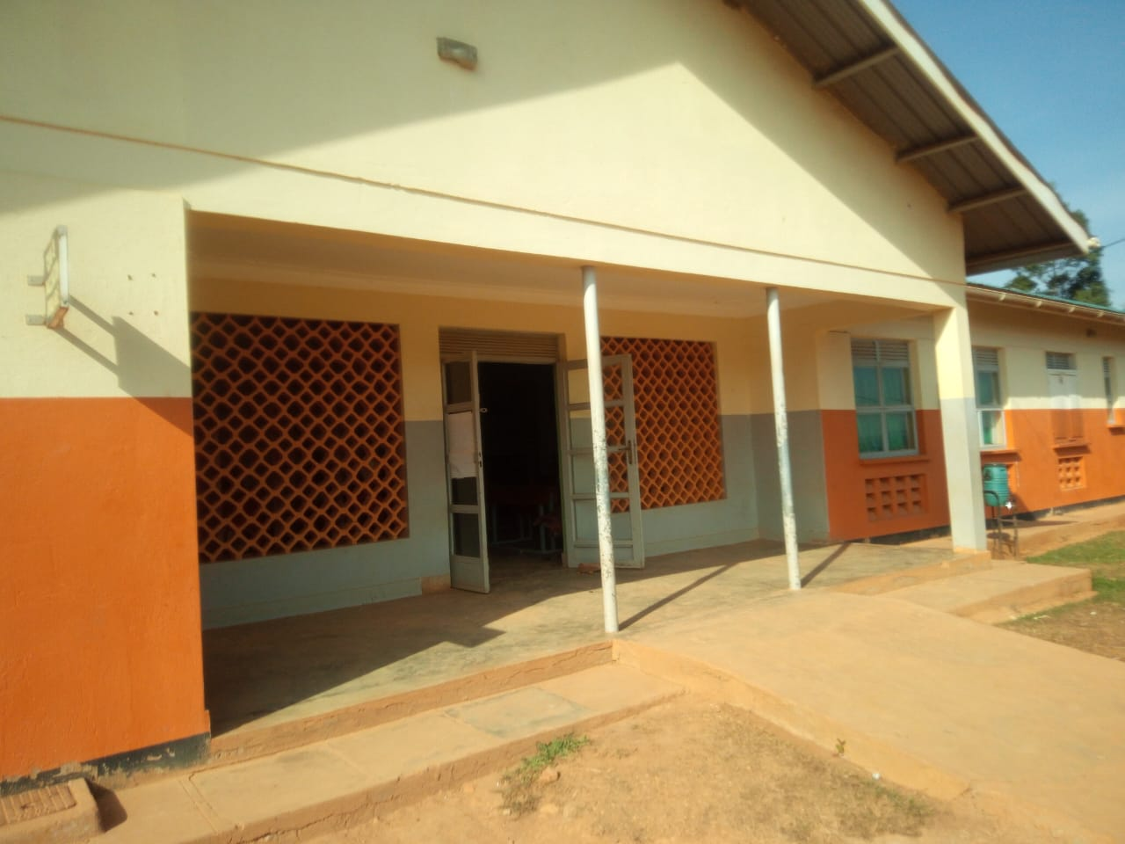

SCHOOL VERIFICATION CHECKLIST

SCHOOL INTERVIEW/DISCUSSION GUIDE

Name of school: MBIRIIZI SEED SECONDARY SCHOOL

1a | Does the Facility have a record of all assets provided under UgIFT.  (Obtain a record and verify if it has the costs and numbers supplied | Yes
1b | If Not ask how many were supplied and when.

2 | How does this facility Maintain (repair/service/replace) the assets provided under Ugift

They have a budget for maintainance incase breakage
M.L.S supplies lab equipments incase of need
Strike rules and regulations are applied

3 | Does the facility take regular record about functionality/ or breakdown of the assets provided?  Nonfunctional/ working, and reasons for non-functionality. | Yes
Some lab chemicals came when they are expired .
They have the records but the person incharge of keeping records was not there at the facility

4 | How has the UgIFT support helped in service delivery in the area, any issues, challenges and any recommendations for better program implementation.

CHALLENGES
The equipments they received are not enough for the school
The buildings which they built are not enough for the population of the students
Contruction of the fence is needed
Libraryshelves and books are needed
Teachers are not enough

PROCEED TO VERIFICATION AFTER THIS DISCUSSION

Recommendatios

Getting more teachers

Building more classblocks for the students

Contructing a fence for security purpose of the students
SCHOOL FURNITURE
(School Desks, Office chairs, Laboratory stools, Book shelves)

Name of LG……LWENGO DISTRICT LOCAL GOVERNMENT Name of SCHOOL…MBIRIIZI SEED SECONDARY SCHOOL

Equipment/ Item | Department | Asset Number | Item  Description | Life in Months | Tag Number ( engrave no.) | Date Of Pur | Date Placed In Service | Recoverable cost | Cost | Acc Dep Cost | Net Book Value | Ytd Deprn | Equipment status | Remarks
Office tables | Education |  | They received 3 wooden |  | Mbirizi SS |  |  |  |  |  |  |  | Good | Functional
Desks | Education |  | They received 102 wooden desks |  | Mbirizi SS |  |  |  |  |  |  |  | Good | Functional
Tables | Education |  | They received 98 wooden |  | Not engraved |  |  |  |  |  |  |  | Good | Functional
Offices chairs | Education |  | They received 12 metallic with cautions |  | Not engraved |  |  |  |  |  |  |  | Good | Functional
Stools | Education |  | They received 102 wooden seats with metallic stands |  | Not engraved |  |  |  |  |  |  |  | Good | Functional
Chairs | Education |  | They received 189 wooden chairs |  | Not engraved |  |  |  |  |  |  |  | Good | Functional
Gas cylinder | education |  | They received 2 but not verified |  | Not engraved |  |  |  |  |  |  |  | Good | Functional

ICT ITEMS TO VERIFY
(Desktop Computer, Server Processor, Network Switch 24 Port, Multipurpose Printer, UPS, Projector, Air Conditioners, Server, CCTV Camera)

Name of LG: LWENGO DISTRICT LOCAL GOVERNMENT Name of SCHOOL…MBIRIIZI SEED SECONDARY SCHOOL

Equipment/ Item | Department | Asset Number | Item  Description | Life in Months | Tag Number ( engrave no.) | Date Of Pur | Date Placed In Service | Recoverable cost | Cost | Acc Dep Cost | Net Book Value | Ytd Deprn | Equipment status | Remarks
CCTV | Lan |  | They received  2 cameras  But not  verified |  | Not  engraved |  |  |  |  |  |  |  | Good | Functional
Projector |  |  | Its 1 but still  packed |  | Not  engraved |  |  |  |  |  |  |  | Good | Functional
Printer |  |  | Its 1 but still  packed |  | Not  engraved |  |  |  |  |  |  |  | Good | Functional
Computers |  |  | Received 28  Black in colour |  | Not  engraved |  |  |  |  |  |  |  | Good | Functional
Air conditioner |  |  | Received 1 but  Not veried |  | Not  engraved |  |  |  |  |  |  |  | Good | Functional

BUILDINGS TO VERIFY
(Non- Residential and Residential, Kitchen, Toilets/Pit latrine Water tanks, Fences etc.)

Name of LG@ LWENGO DISTRICT LOCAL GOVERNMENT Name of SCHOOL…MBIRIIZI SEED SECONDARY SCHOOL

Equipment/ Item | Department | Asset Number | Item  Description | Life in Months | Tag Number ( engrave no.) | Date Of Pur | Date Placed In Service | Recoverable cost | Cost | Acc Dep Cost | Net Book Value | Ytd Deprn | Equipment status | Remarks
Administration block |  |  | 1 block with office and staff |  | Not  engraved |  |  |  |  |  |  |  | Good | Functioning
Class block |  |  | 3 blocks with 2 classrooms each |  | Not  engraved |  |  |  |  |  |  |  | Good | Functioning
Staff block |  |  | 3 blocks with 2 rooms each |  | Not  engraved |  |  |  |  |  |  |  | Good | Functioning
Toilets |  |  | 6 blocks with 3 rooms each |  | Not  engraved |  |  |  |  |  |  |  | Good | Functioning
Kitchen |  |  | 1 kitchen |  | Not  engraved |  |  |  |  |  |  |  | Good | Functioning
Water tanks |  |  | 2 tanks with different litres |  | Not  engraved |  |  |  |  |  |  |  | Good | Functioning
Lab block |  |  | 1 block for sciences |  | Not  engraved |  |  |  |  |  |  |  | Good | Functioning
ICT/Library |  |  | 1 block for ICT and library |  | Not  engraved |  |  |  |  |  |  |  | Good | Functioning
Main hall |  |  | 1 block |  | Not  engraved |  |  |  |  |  |  |  | Good | Functioning
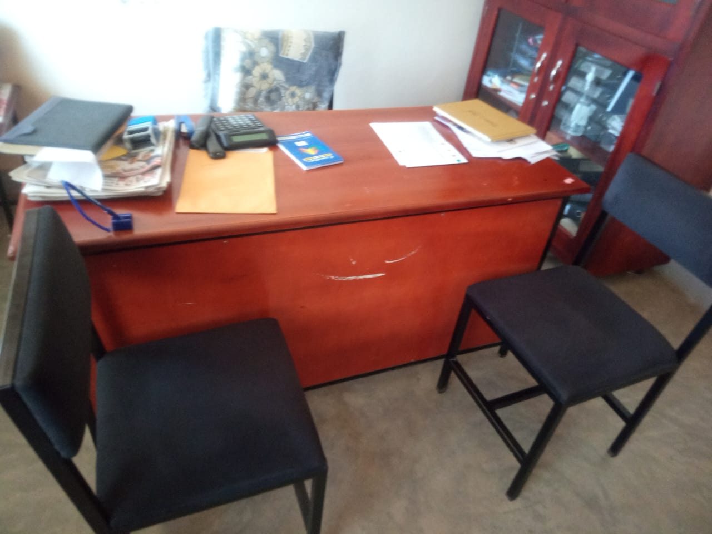
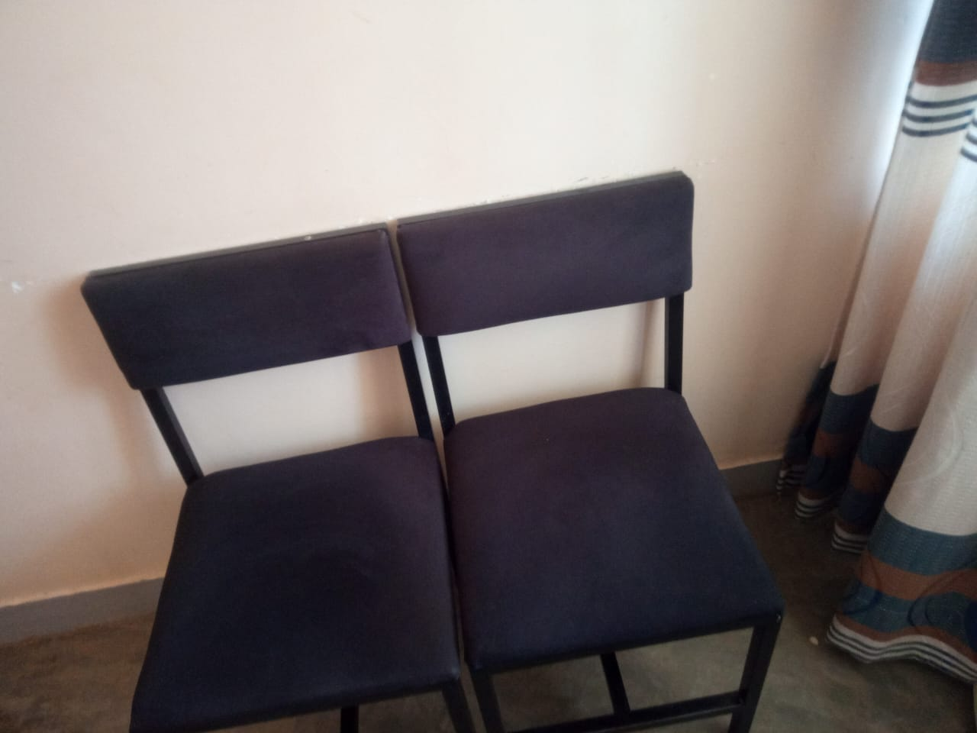
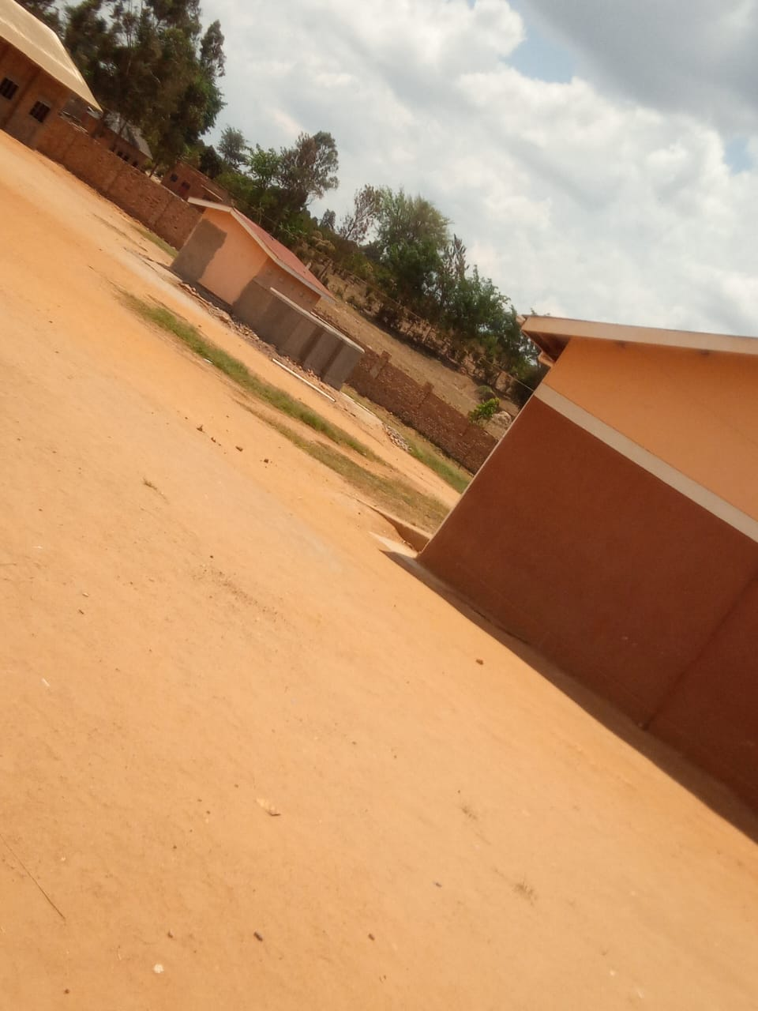
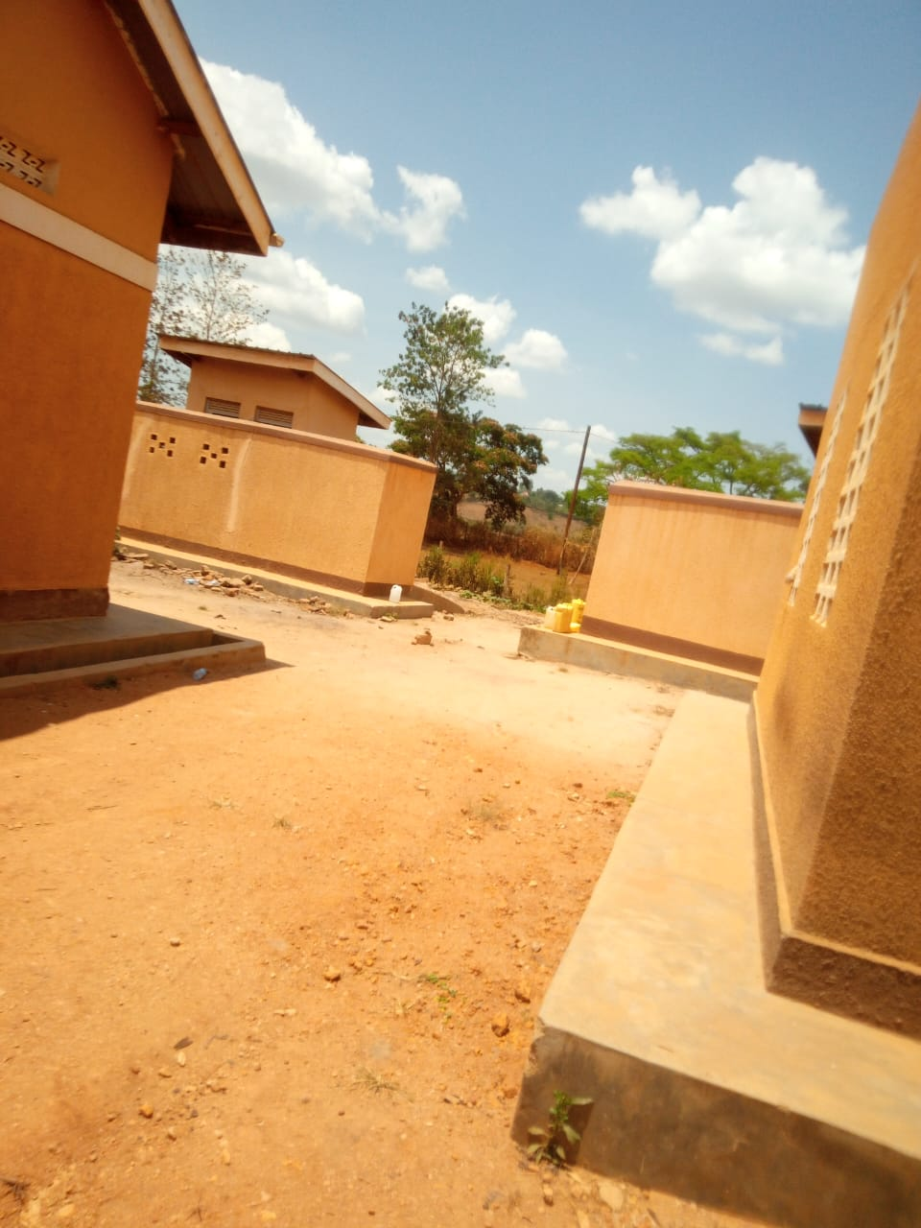
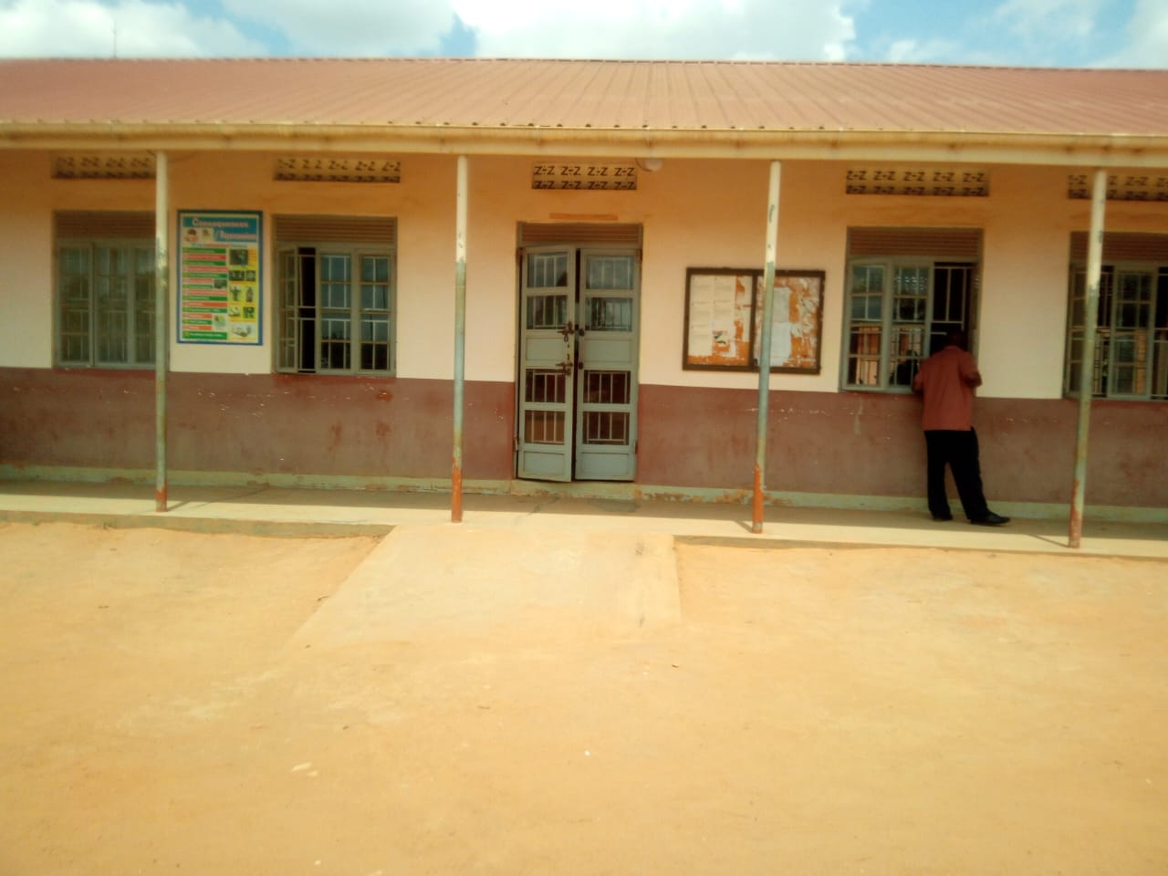
Administration block staff toilets students toilets office chairs

Office table and chairs

